UAV Quadcopter

California State Polytechnic University, Pomona

|  |  |  |  |
| --- | --- | --- | --- |
| **Chad Ryan**  **Cal Poly Pomona**  **3801 W Temple Ave, Pomona, CA 91768 cpryan@cpp.edu** | **Liam Yeargin**  **Cal Poly Pomona**  **3801 W Temple Ave, Pomona, CA 91768 lnyeargin@cpp.edu** | **Kory Shopp**  **Cal Poly Pomona**  **3801 W Temple Ave, Pomona, CA 91768 kshopp@cpp.edu** | **Peter Tiet**  **Cal Poly Pomona**  **3801 W Temple Ave, Pomona, CA 91768 ptiet@cpp.edu** |

*Abstract - This project implements a UAV quadcopter using a Raspberry Pi as the central controller unit. This was done via coding the controller, a Raspberry Pi 4, with python scripts to generate pulse width modulated (PWM) signals. These signals are then boosted by an active amplifier circuit using an operational amplifier (OPAMP) and sent to four electronic speed controllers (ESC). These electronic speed controllers then activate and control the speed and behavior of the four brushless motors attached to propellers that generate the lift for the quadcopter. The in-flight characteristics of the UAV are controlled by a gyro-accelerometer combination chipset, an MPU6050. The MPU6050 controls the pitch and speed of the UAV by changing the revolutions per minute (RMP) of the motors, dynamically maintaining stable flight characteristics. All control elements of the board, excluding the ESCs/motors/props/battery, are integrated into a printed circuit board (PCB). This PCB is then inserted into the UAV’s chassis and connected to the PCB excluded elements listed above. Finally, upon activation the elements outlined above will then fly the drone as determined by user input.*

Table of Contents

1. Introduction 1

2. Body 1

3. Conclusions 9

References 10

Biography 10

1. Introduction

*Introduction –* This Senior Project aims to design, test, and build a flight-controller & printed circuit board that will both integrate with commercial ESC’s (Electronic Speed Controllers) & DC brushless motors (typical motors used for drone applications) in order to create a UAV Quadcopter. A Raspberry Pi 4 is chosen to replicate the flight-controller. The printed circuit board will be designed to not only house the Raspberry Pi 4, but to also electronically support the Pi 4. We went into this project knowing that the Raspberry Pi 4 is not a typical or efficient choice for a flight-controller, yet took this as an opportunity to overcome the challenges that this decision would present to us. The goals of this project are to create/program a flight-controller out of a microcomputer/controller, gain successful control of the DC brushless motors, and to eventually have the UAV lift off of the ground with no hardware support (wirelessly control the UAV, in an isolated configuration).

2. Body

*Raspberry Pi 4-* The microcomputer that was selected to be used is the Raspberry Pi 4. The Pi 4 was selected for its Python code support, GPIOs, reasonable cost, and ability to be programmed in a headless configuration (allows for fast program adjustments while testing).

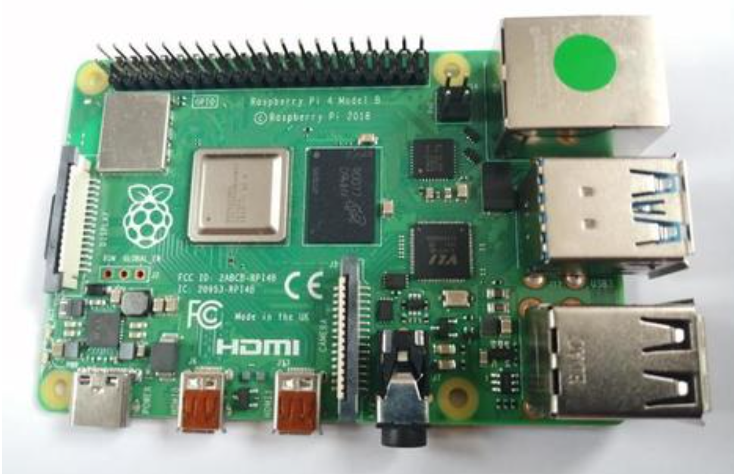

*Figure 1- Raspberry Pi 4 Microcontroller*

A reason to use the Raspberry Pi 4 as the main controller is that an SSH, or secure shell, was able to be used. SSH is an encrypted networking technology that enables a user to manage the Pi from a command line over a network. By using SSH with the Pi, a terminal session could be opened by using the command window of the computer and allow the sharing of data. This terminal window is where the coding was implemented.

The Pi is capable of operation in a headless configuration. Headless mode is when the Pi wirelessly or locally (Ethernet LAN) communicates with an external computer. Being in headless mode was beneficial for this project because this allowed for the transfer of data without requiring the Pi to be connected to the monitor, or in some cases without a wired connection to the Pi. Headless mode also proved to be beneficial because it was easy to integrate with the Pi on and off the Quadcopter. This allowed for the configuration of the Pi to be similar when the Pi was attached to the Quadcopter.

To maintain an accurate record for the project, GitHub was used to maintain all files. <https://github.com/ryanchad22/UAV_Quad>

The Pi 4 supports a 40 pin GPIO (general purpose input/output) layout. GPIO is used for both incoming and outgoing signals from the Pi. For the PWM, the pins that were set to be output pins are pins 11, 16, 22, and 37. The four pins were designated to output the PWM signal to the ESCs attached to the motors.

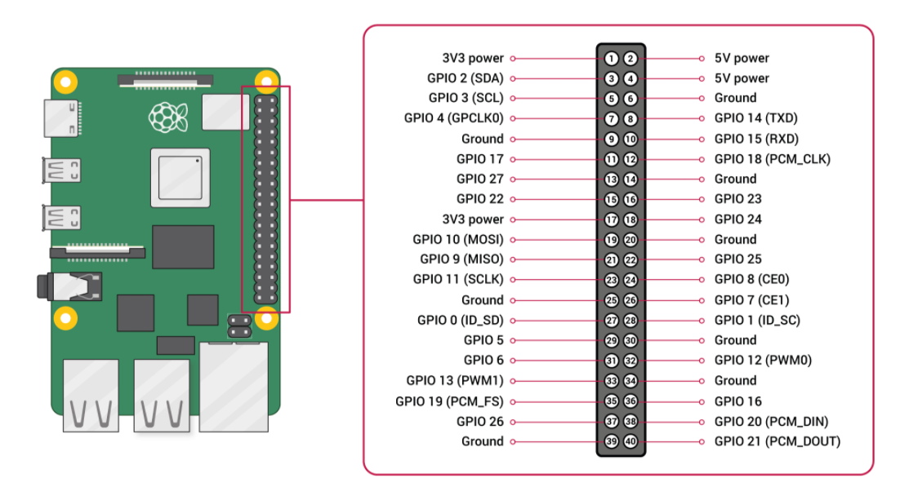

*Figure 2- Raspberry Pi 4 GPIO layout*

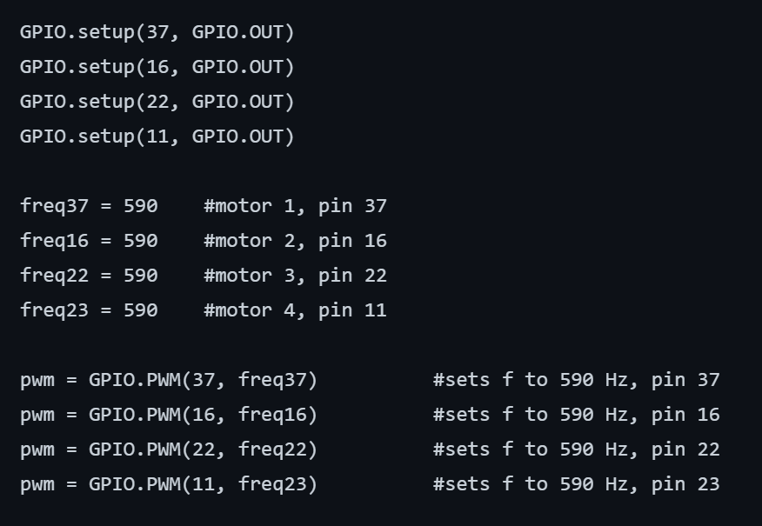

*Figure 3- Configuring the 4 output pins of the Raspberry Pi with Python*

After conducting the PWM tests on the ESCs, it was found that the desired frequency to set the system to would be 590Hz. This initial PWM frequency is used to calibrate and initialize the ESCs to operate within our desired frequency range (~370 Hz to ~590 Hz). Motor RPM increases with a decrease in PWM frequency, an inverse relationship between PWM frequency and motor RPM

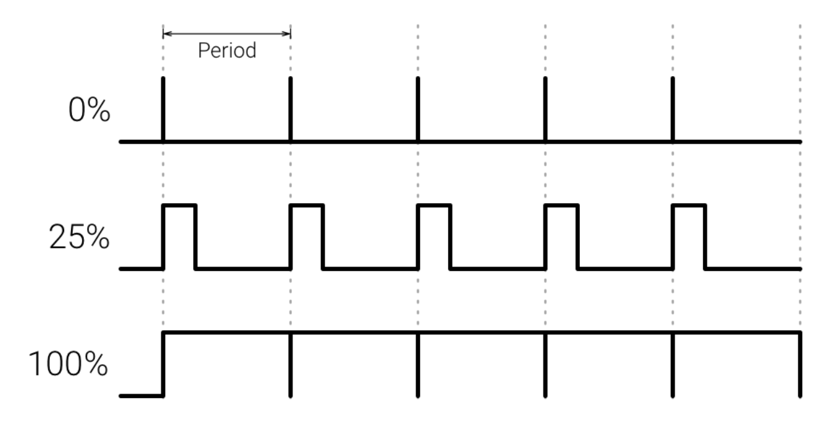

*Figure 4- PWM signals showing various duty cycles*

The Raspberry Pi was used also to communicate with the accelerometer and gyroscope. The component selected for this was the MPU6050. The MPU6050 is designed to measure acceleration, orientation, and temperature. The gyroscope sensors inside the MPU detect and measure the angular motion of the Quadcopter. The other main component inside the MPU is the accelerometer. The accelerometer is used to give acceleration in X, Y, and Z directions. The MPU is a 6-axis motion tracking device. This can be done by detecting rotations about the X, Y, and Z axis. When the gyros are rotated, the MPU sends a signal that will produce a voltage proportional to the angular rate. This voltage becomes digitized using ADCs. An ADC, analog to digital converter, converts analog signals to digital signals. This converted digital signal is then sent back to the Pi 4 as the master of the circuit. Communication between the MPU and the controller is done using I2C protocol.

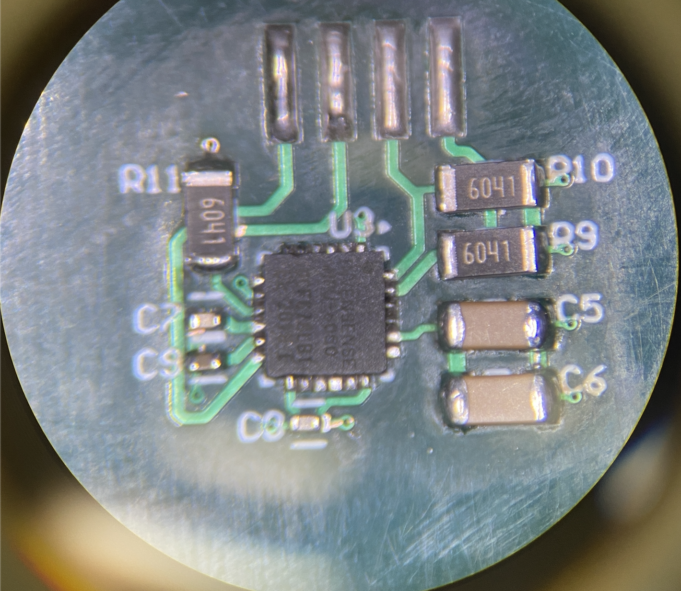

*Figure 5- MPU6050 on DPIE*

*ESC-* ESCs, or Electronic Speed Controllers, are devices that allow controllers of a drone or Quadcopter to control and adjust the speed of the brushless motors. The ESC interfaces between the flight controller and the motor. Through this connection, the ESC allows the controller to control the speed of the motors. Brushless motors require an ESC because brushless motors lack the commutator which uses physical contact of the motor’s windings to spin the motor. Since each brushless motor requires an ESC, there are four attached the Quadcopter. The ESC that was selected for this project is the Spedix IS30 2-4S BLHeli_S Dshot600 30A ESC.

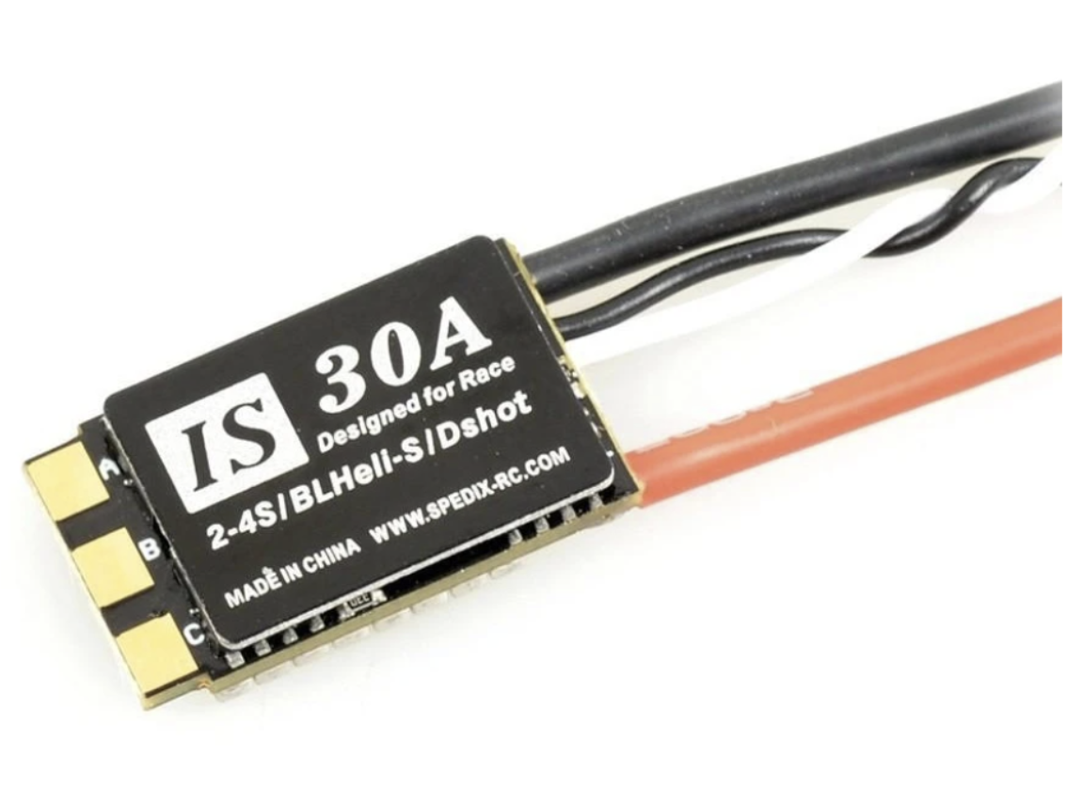

*Figure 6- Spedix IS30 2-4S BLHeli_S Dshot600 30A ESC*

Inside a typical ESC are six MOSFETs. These MOSFETs are used as switching MOSFETs for the motors. When the ESC receives the PWM signal from the Pi, the ESC is telling which MOSFET to turn on and off by providing 5 volts of voltage from the PWM. When the PWM signal switches from low to high, this signal is telling which ESC to off and which to turn on. Each MOSFET is connected to a different phase of the motors cycle. By changing which MOSFET is turned on and which is turned off, this controls the current that is being provided to the coils. This cycle of switching between the MOSFETs creates the magnetic pull inside the motor. The faster the PWM changes the provided voltage to the ESC the faster the motor will spin and vice versa for how slow the motors spin.

*Motor -* The motor selected to be on the drone is a brushless DC motor. The brushless DC motor is one of the most common DC motors that used. A brushless DC motor consists primarily of a stator and rotor. The rotor is a permanent magnet with two magnetizing poles. The stator consists of coils arranged below:

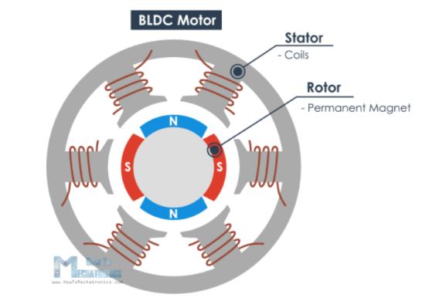

*Figure 7- Brushless DC Motor*

Once current is applied, the coil will generate a magnetic field that will attack the rotor permanent magnet. If the coils are activated one after, the rotor will keep rotating due to the face interaction between the magnet and the electromagnet. The following figure displays rotation of the motor.

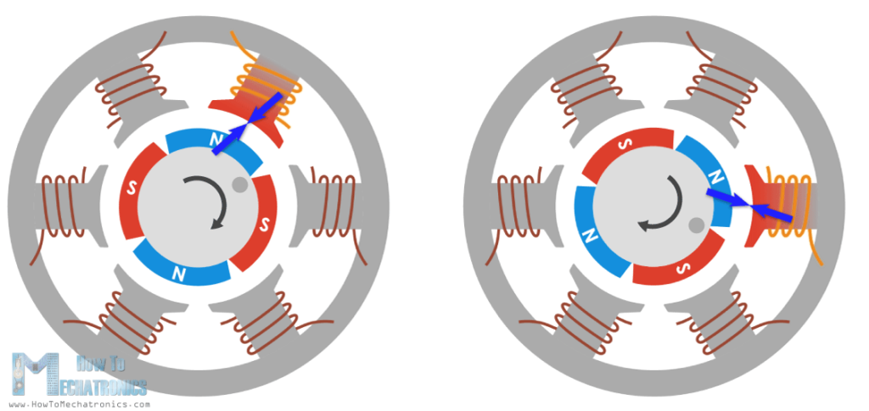

*Figure 8- Rotation of Brushless DC Motor*

The efficiency of the motors can be increased by winding two opposite coils as a single coil in a way that will generate opposite poles to the rotor poles, obtaining a double magnetizing force.

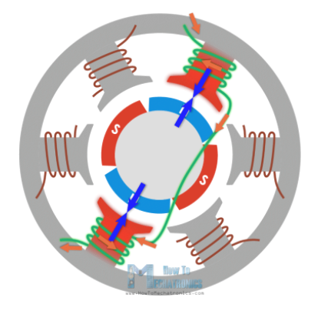

*Figure 9- Optimal Rotation of Brushless DC Motor*

To make the rotor rotate a full 360 degrees cycle, the coils need to go through a six-step process.

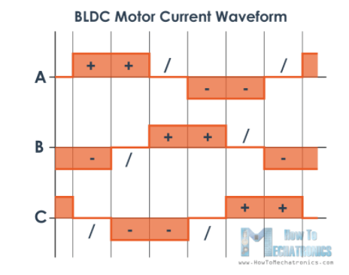

*Figure 10- Current Waveform of a BLDC Motor*

According to the table, the polarity of each phase alternates, switching from positive current, negative current, and phase turning off. Each phase always has a different polarity to ensure that the polarity differences of each pole’s changes, enabling the motor to be always rotating. The current that goes to the motor is controlled by an electronic speed control (ESC), which in turn, change the motor to its appropriate speed.

Specifically, for the drone, the BR2216 is selected. The BR2216 is an 810 KV brushless DC motor made primarily for racecar or drone use. The kit contains two motors each, clockwise (red cap) and counterclockwise motors (black cap). The figure below displays the BR2216 motors:

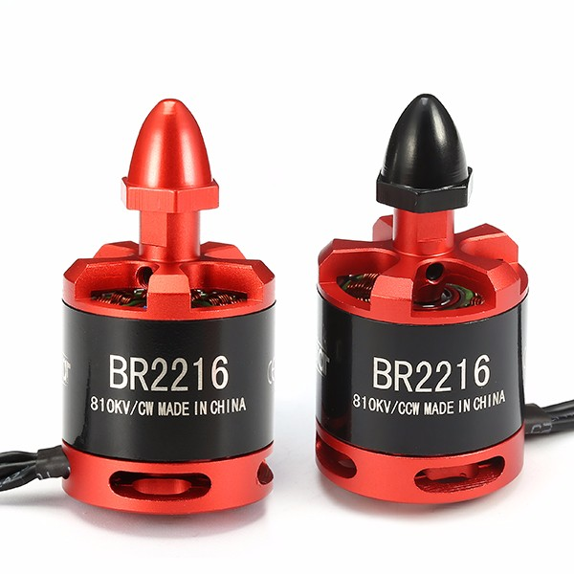

*Figure 11- BR2216 DC Motors*

The main benefits of these motors are that they are very light and efficient. The motor’s rotations per minute (rpm) can be controlled continuously at maximum torque, which means that they are suitable for maintaining the drone hover position. The second advantage is motor controllability. The motor’s speed can be controlled by PWM signals from the Pi 4 applied to the ESC. In turn, the motors deliver the precise torque and RPM needed for flight. By being able to control the rpm, flight control is achieved, and power consumption is reduced.

The clockwise motors are placed at the top right and bottom left and the counterclockwise motors are placed at the top left and bottom right of the frame. The reason why the CW and CCW motors are placed diagonally is to only give vertical acceleration at a uniform RPM, across all motors. The configuration negating undesired vectors of acceleration at a hover. A diagram of the positions of the motor are shown below:

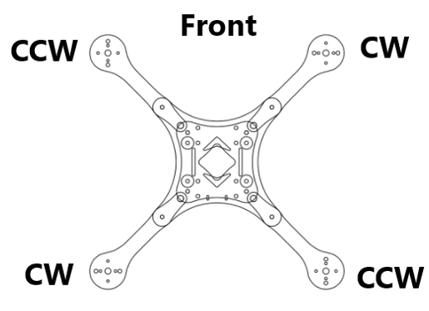

*Figure 12- Positions of Motors*

Aside from the weight, efficiency, and cost-effectiveness of the motors, the motors have an operating voltage at 7.4V-14.8V and can be optimally compatible with a 14.8V LIPO battery. Due to its compatibility of the LIPO battery, the drone can be effectively powered with minimal weight. The motor’s schematic and characteristics data are shown below:

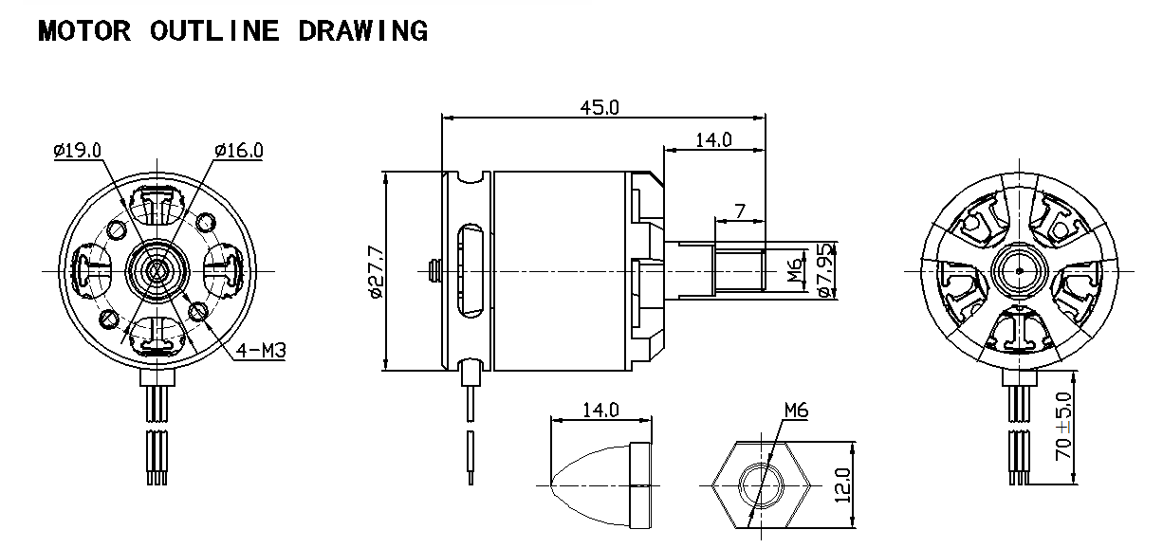

*Figure 13- Schematics of BR2216 Motors*

*Propellers -* The selected propellers for the drone are an RAYCorp 10-inch quadcopter performance propellers. The selection of the propellers is based on 5 main variables, the size, pitch, blade configuration, material, and shape. The figure below is the selected drone propellers:

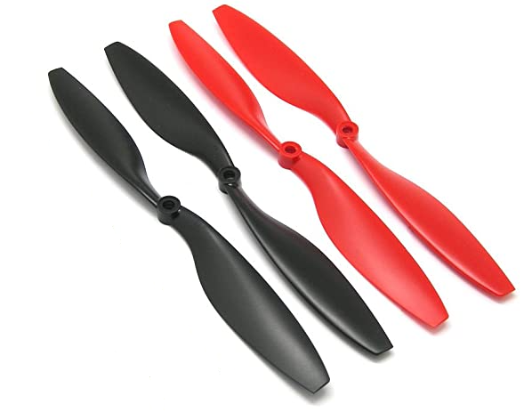

*Figure 14- RAYCorp 10-inches quadcopter propellers*

The propeller is 10 inches, which is relativity larger compared to other drone propellers. The size of the propellers is directly correlated to thrust, responsiveness, and the balance that the drone will have in the air. The larger propeller will sweep though more air but will take more energy to get it spinning and will respond slower to the motor input. The main benefits of a larger propeller are increased thrust, better stability while hovering, and more control when making changes to the direction.

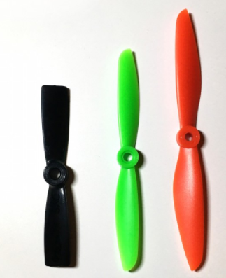

*Figure 15- Difference Propeller Sizes*

The propeller has a high pitch with a 4.5 shaft diameter. A higher pitch results in an increased thrust and top end speed, but less torque. Additionally, the propeller will respond to the motor input slower, use more power, and is efficient when the drone is moving relativity quickly. While 5 shaft diameter is considered a high pitch propeller, the 4.5 shaft diameter provides a good blend of responsiveness/torque and speed.

Blade configuration is one of the most important factors in selecting the propeller. The blade configuration refers to the number of individual blades on a propeller. The blade configuration of the selected propeller is a 2 bladed propeller. Picking a 2 bladed propeller are more efficient because only two blades are creating drag and provide flight balance.

While the benefit of having more blades increases the amount of thrust and control in the air, the trade-off of this is a slower response time and increase power consumption to move the propeller. Less blades are preferred due to faster motor response with less thrust. Lastly, increasing the number of blades is not as efficient as increasing the propeller size, which is the reason why the selected propellers are larger compared to the average size.

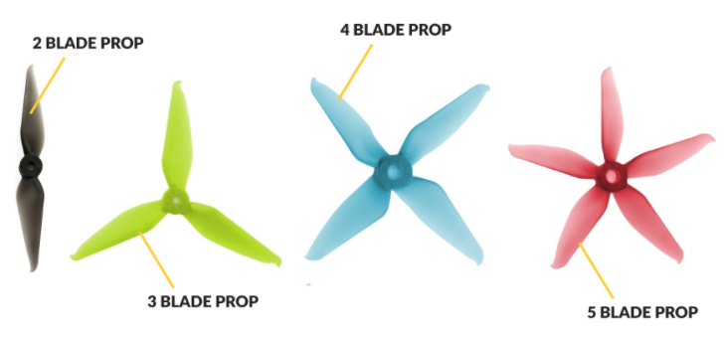

*Figure 16- Difference Blade Configurations*

The material of the propeller is plastic. Plastic blade is stiff for their weight and allows the propeller to maintain shape regardless how fast it is moving or changing direction. If the drone were to crash, the propellers would be durable enough to withstand the collision/fall damage. Lastly, plastic blade is very cost-effective since the material itself is not expensive.

The shape of the propeller determines contributes to the amount of thrust and drag for the drone. The bigger surface area of the propeller will generate more thrust but creates more drag and consumes more power. The shape of the selected propeller is a hybrid bullnose (HBN). The hybrid bullnose is the most efficient shape because it has more surface area but, generates less thrust. In the figure below shows both common propeller shapes, the hybrid bullnose (top) and the bullnose (bottom).

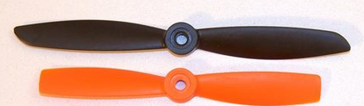

*Figure 17- Difference Propeller Shapes*

*Pulse Width Modulation, PWM* - To instantiate the I/O to generate a PWM signal to control the ESCs, the open-source Pi python libraries were used. More specifically using the general-purpose input output (GPIO) library, the Pi 4’s pins 11, 16, 22, and 37 are primed as software PWM outputs according to Python coding language methods. They are instantiated with a frequency value, 590 Hz, for each pin. Next, the duty cycle, 54%, is instantiated; then the. start command is used to output a PWM signal from each of the pins respectively. However, for ESCs the Pi’s PWM GPIO pin output voltage of 3.3V was not enough to drive the ESC’s MOSFETs. To remedy this, we created an active amplifier circuit using an OPAMP. The OPAMP, specifically the OP284ESZ, was set up in a standard non-inverting amplifier setup where the gain G of the circuit is controlled by its resistive values R1 and R2. Using a 6.04K resistor for R1 and a 3k resistor for R2, this giving us a ~1.5 gain according to the equation in figure #. After passing the active amplifier, the Pi’s PWM signal was boosted from 3.3V to approximately 5V. This voltage was now enough to drive the MOSFETs gates in the ESC. Therefore, the PWMs voltage was now sufficient to control the MOSFETs that control the current flowing into the windings of the motors. This in turn controlling the RPM of motor as determined by the frequency of the PWM signal in the Pi’s master code allowing for fine motor control. As referenced in the data section. as the frequency decreased to lower limit of 392 Hz, the RPM increases. In addition, as the frequency increased to an upper limit of 642 Hz, the RPM decreases.

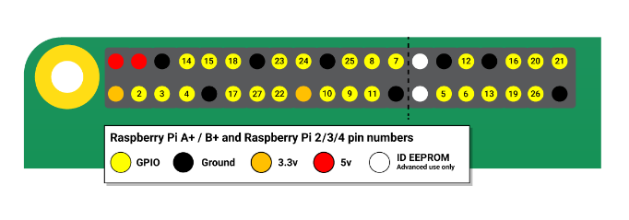

*Figure 18 Raspberry Pi 4 Pinout*

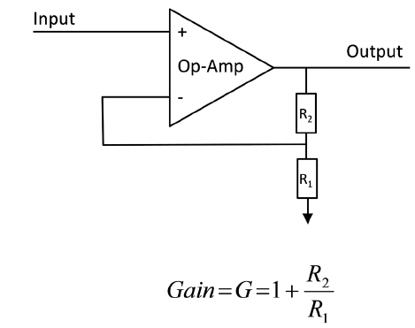

*Figure 19 - General diagram of a non-inverting amplifier*

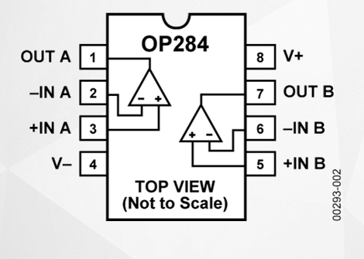

*Figure 20 OP284ESZ 284 pinout*

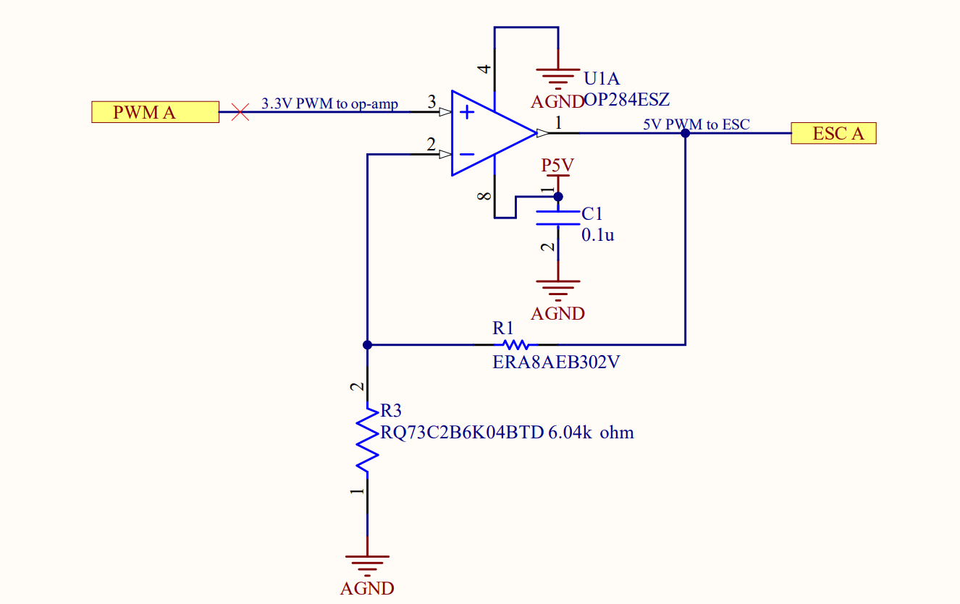

*Figure 21 - PWM amplifiers schematic as they appear on the DPIE PCB*

*Voltage Regulator* - To power the Raspberry Pi and other components while in flight, a battery was needed. The battery that was selected was a Youme 4S Li-Po 6200mAh. This battery provided power to all the onboard components, most importantly the ESCs, which require high amperage in comparison to other components. However, the maximum input voltage to allowed by the Pi 4 is 5V so a voltage regulator was needed to step-down the operating voltage for the Pi. This was implemented by a voltage regulator integrated circuit component, the L4940D2T5-TR. This regulator takes in a maximum voltage of 17V, in our case ~15V from the battery, and steps down the voltage to 5V at 1.5A. This output is now the correct voltage and sufficient amperage for power needs of the Pi in operation.

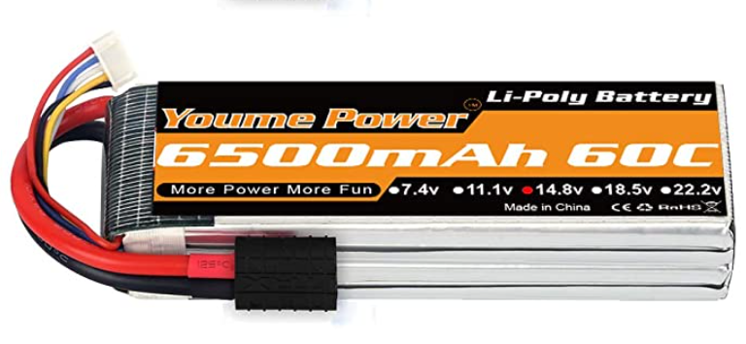

Figure 22 - UAV onboard battery

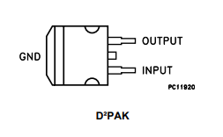

*Figure 23 -*

*L4940D2T5-TR Voltage Regulator pinout*

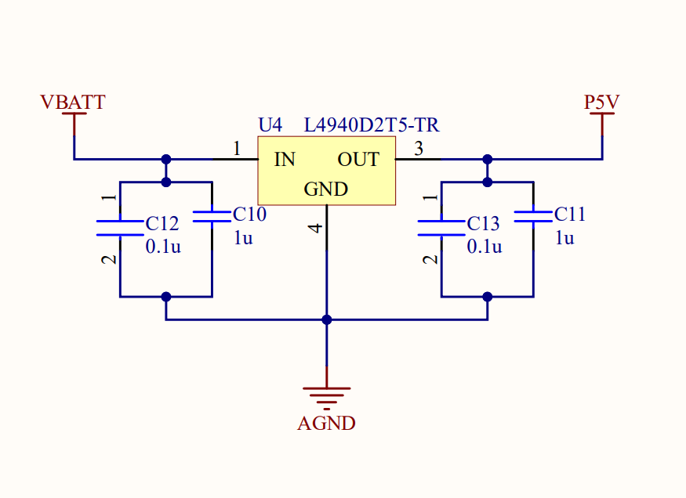

*Figure 24 - Voltage regulator schematic as appears on the DPIE PCB*

*DPIE (Digital Power Interface Electronics) –* A PCB (printed circuit board) designed to accommodate for the PWM amplifiers, drone chassis, MPU6050, and for housing the Pi. Two DPIE boards are used for the drone assembly, a “top” board and a “bottom” board.

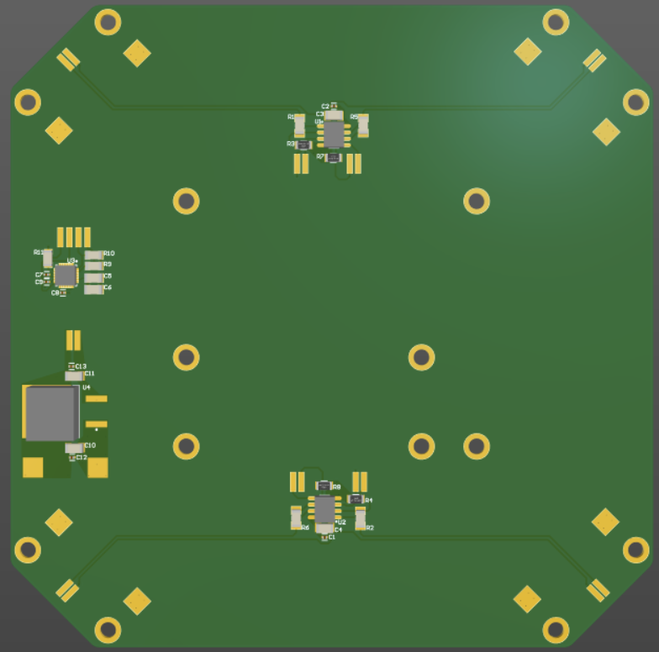

*Figure 25 - DPIE 3D View*

A combination of tracks, polygon pours, via’s, and plane layers are used to connect power, analog signals, and digital signals from and to the Raspberry Pi 4,

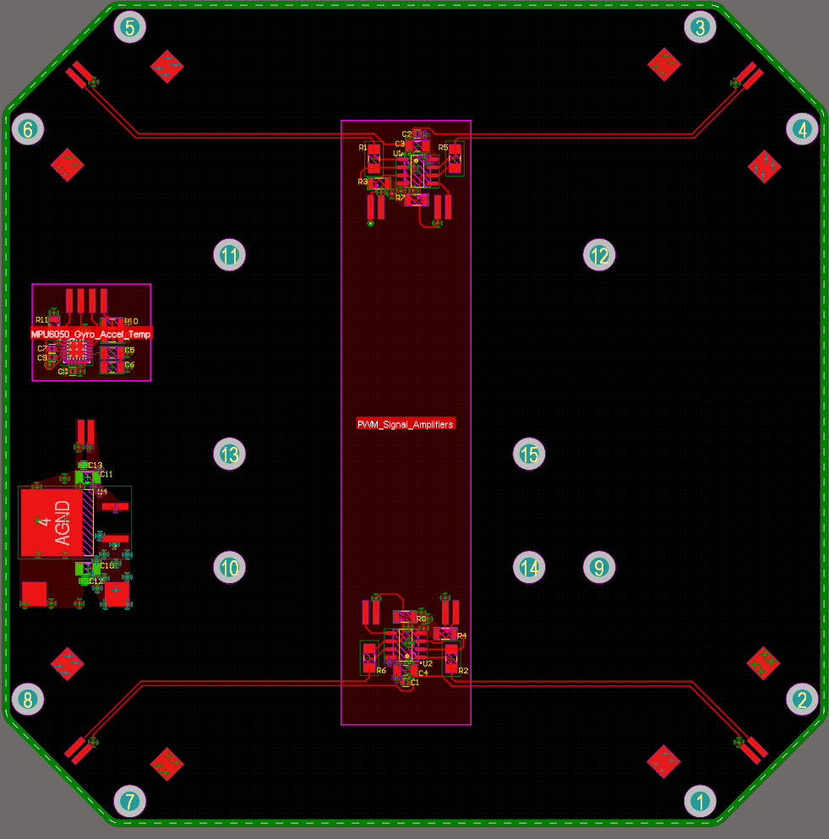

*Figure 26 - DPIE 2D View*

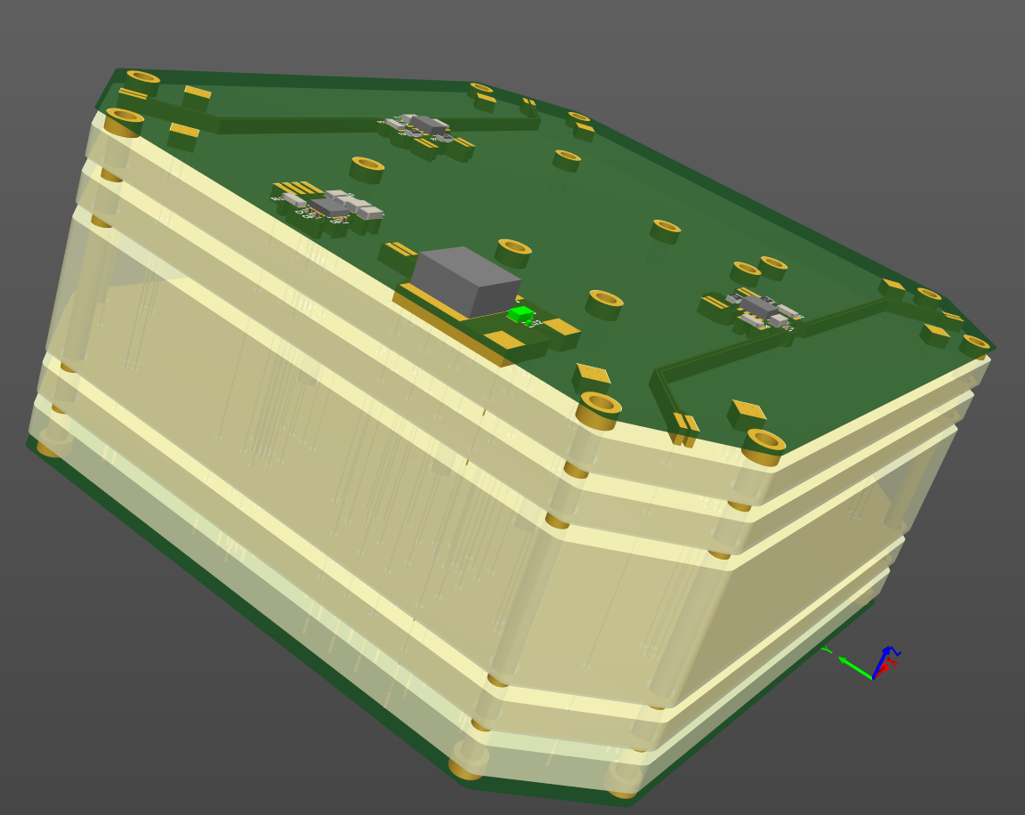

*Figure 27 - 3D View w/ Board thickness scaled to show layer stack*

Plane layers in the layer stack were dedicated to power & Ground of the system. This includes 5V power, Battery Power, and AGND (Analog Ground)

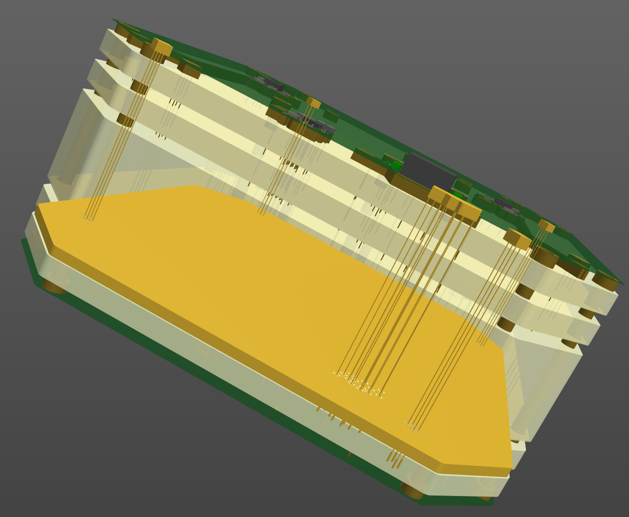

*Figure 28 - Battery Voltage Plane, Via’s, Tracks, & Pads*

PWM amplifiers are symmetrical and are on either side of the DPIE. Each OP284 contains two operational amplifiers. Polygon pours were used for power connections, while tracks were used for PWM signals. Differential PWM signal pairs leave either side of the OP284, eventually terminating at solder pads on each corner of the DPIE (to eventually be soldered onto ESC PWM input wires).

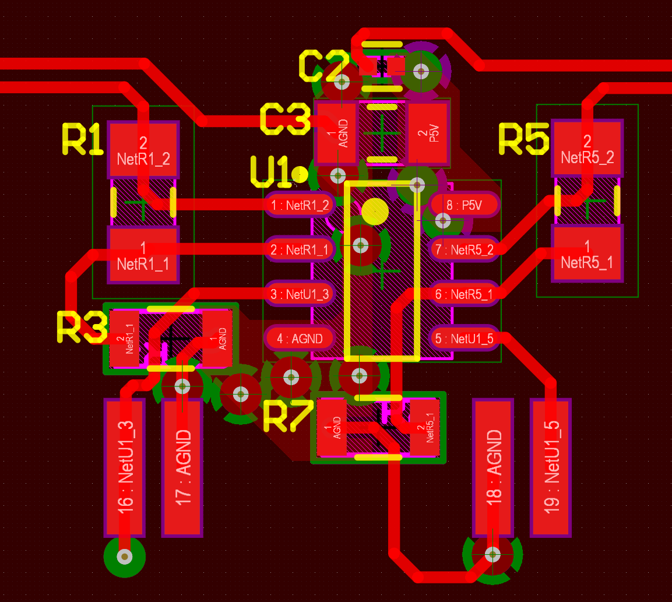

*Figure 29 - OP284 Circuit Layout*

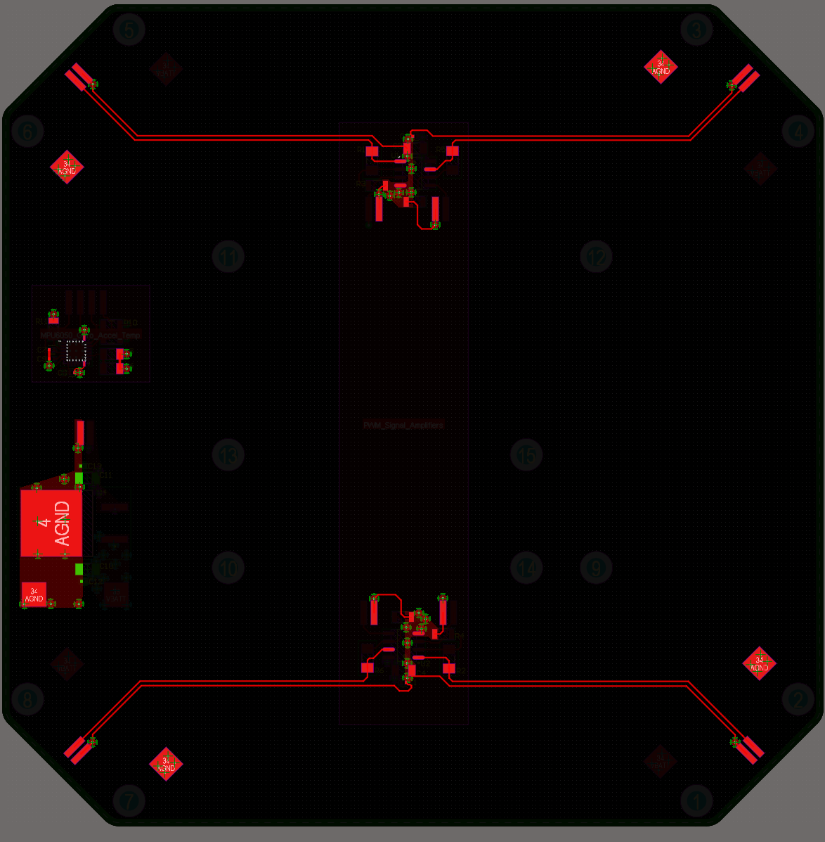

*Figure 30 - PWM Differential Pair Paths*

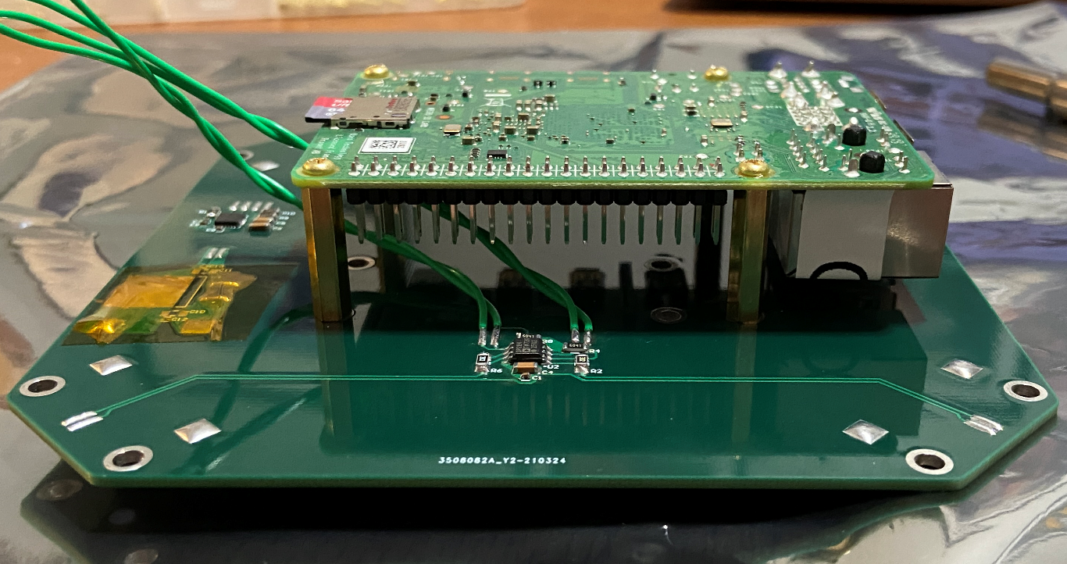

*Figure 31- DPIE with RPi 4*

The Voltage Regulator L4940D2T5-TR is placed on the DPIE nearby a few capacitors of different sizes and values. Polygon pours and via’s were used to not only electrically connect the L4940D2T5-TR, but to also act as a heatsink (the L4940D2T5-TR gets very hot during operation)

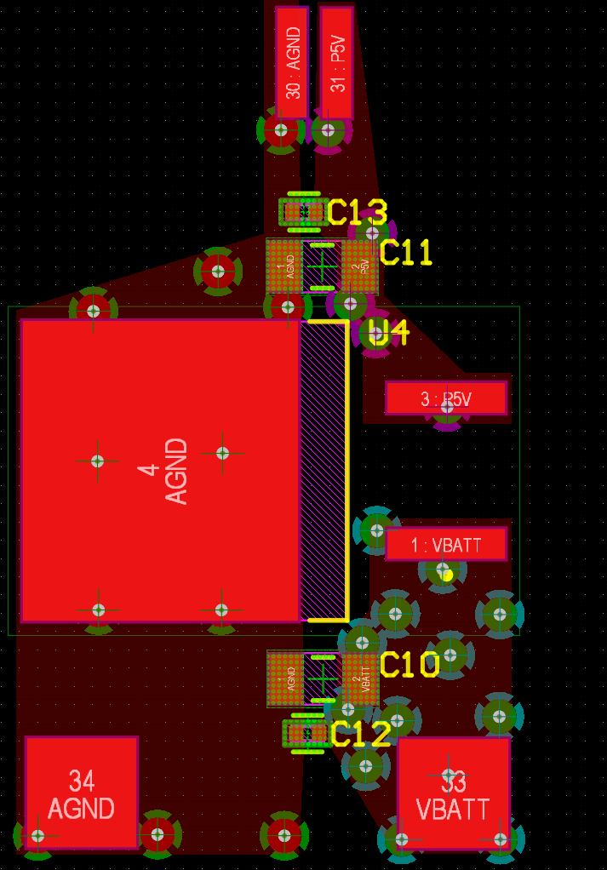

*Figure 32 - Voltage Regulator L4940D2T5-TR*

MPU6050 design terminates with 4 solder pads, GND, SDA, SCL, and AN0. The MPU6050 receives power through via’s nearby its solder pads.

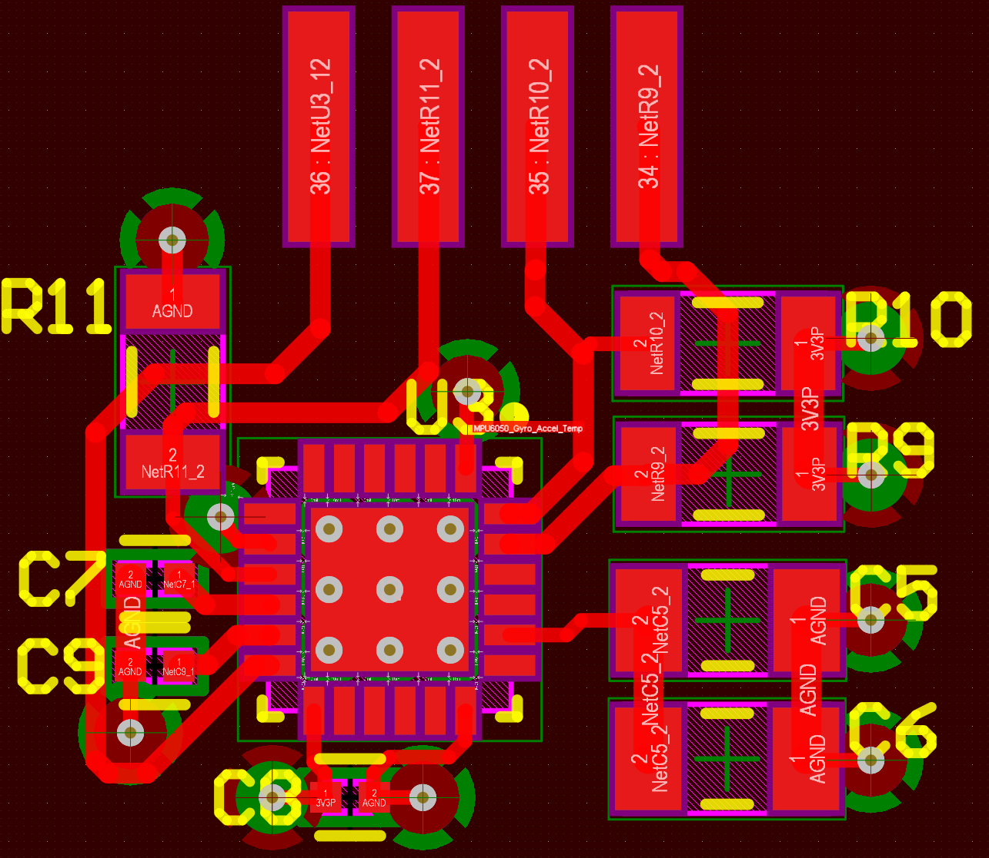

*Figure 33 - MPU6050 Layout*

The mounting holes on the DPIE are designed for mounting the arms of the drone, Raspberry Pi, and potentially a Raspberry Pi Pico onto the DPIE. The center mounting screw holes that make rectangular shapes are for the Raspberry Pi boards that can be used to operate the ESCs. The outer mounting holes towards the edges of the DPIE are for mounting the arms, the tops and bottoms of each arm, providing a stable chassis for the drone.

*Python Programming –* All Python programming in this project was done in a headless configuration. Rather than using an IDE, we used the terminal via SSH. Once SSH’d into the Pi 4, we would navigate to the desired directory (using commands “cd” & “ls”) and then create the text file using the “echo” command. Following, we would send a “nano” command to open the text file that we created. From there, Python code would be generated by the user, and then ran using a “python” command. This configuration increased accessibility in regards to editing and programming in both subsystem and system-level tests.

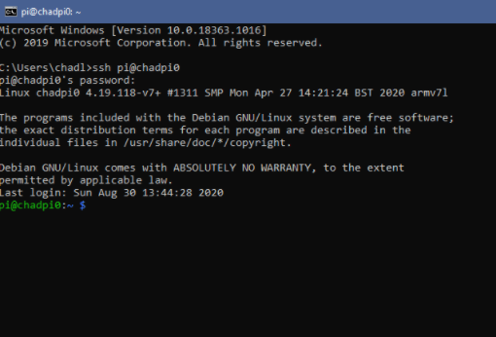

*Figure 34 - Raspberry Pi 4 Terminal Accessed via SSH*

Two libraries were used to assist us interface between software and hardware. The “RPi.GPIO” library was used to help us generate and modulate PWM signals on 4 different GPIO pins. The “time” library was used to help add pauses to the program (this library is not used in the final development code, but it was used throughout the project).

Software-generated PWM signals were used to control the DC brushless motors (interfaced by the ESC’s). Each PWM signal starts at a duty cycle of 54% at a frequency of 590 Hz. At this frequency and duty cycle combination, the ESC’s initialize and start to slightly spin the motors.

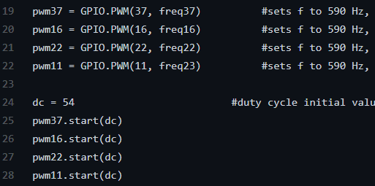

*Figure 35 - PWM Initialization*

Pulse Width Modulation was performed by allowing the user to input an integer while the program is running. Given integer values were predetermined to adjust PWM signals by changing the frequency of the signal(s), allowing the user to adjust frequency of all four PWM signals simultaneously, or two control frequency of each PWM signal individually

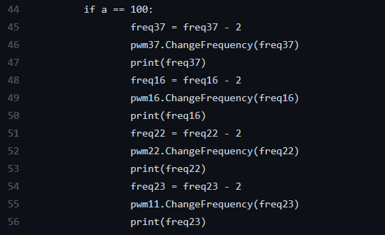

*Figure 36 - Simultaneous PWM Frequency Decrease upon input value “100”*

The Python scripts generated do not reflect the final code that would be used in a commercial or completed quadcopter. This code is more of development code used to help us design, revise, test, and analyze the drone’s behavior. The initial goal of this project was to have the drone float in a stabilized state (stability from MPU6050 telemetry feedback loop). This goal was not met and was dropped, partly due to the current COVID-19 situation, preventing project members from interacting with and supporting each other in person. As a result, MPU6050 functionality was tested and proven to be successful, but was never implemented into a feedback loop to stabilize the quadcopter, abruptly ending Python development for this project.

*Final Tests –* Final tests of the UAV Quadcopter included repeatability tests of the lift and stability produced by the drone. Each test started with a uniform 590 Hz, 54 % duty cycle PWM signal sent to each ESC. This uniform PWM signal initializes each ESC to work within our expected frequency range.

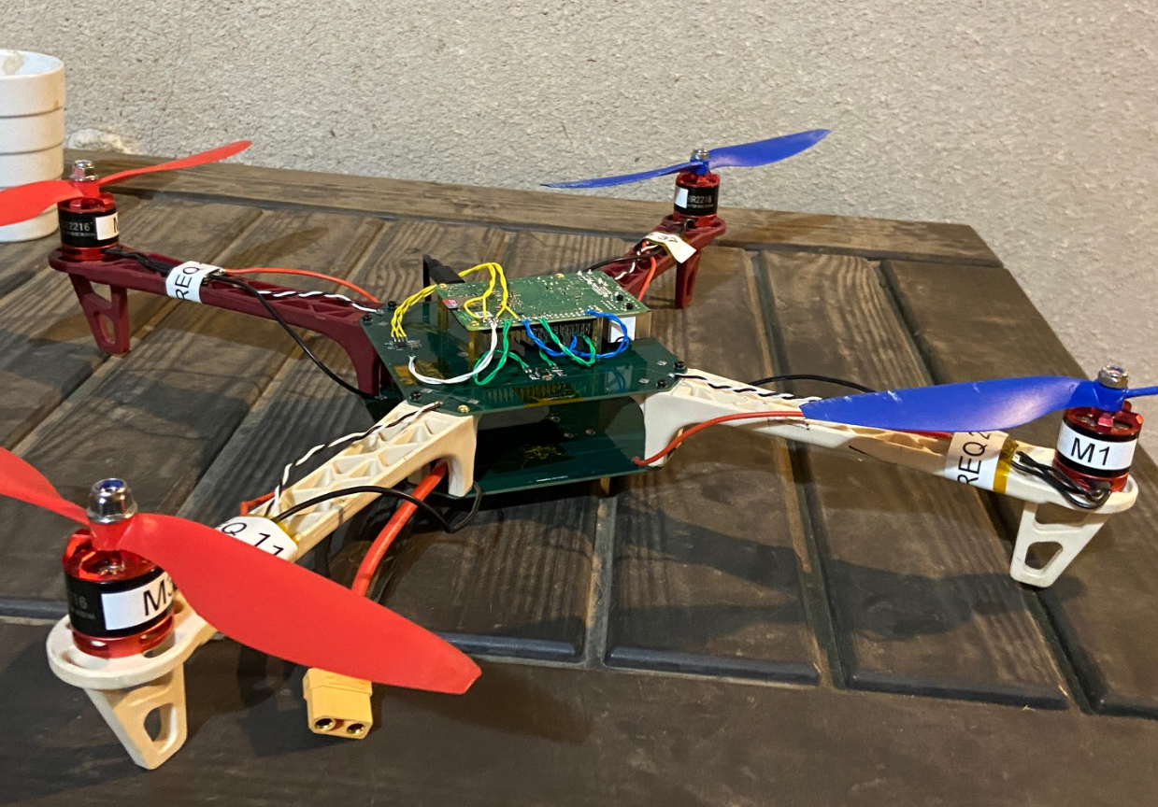

*Figure 37 - UAV Quadcopter Assembly*

The first few tests verified that the UAV is capable of lifting itself off of the ground. At ~50 % max motor speed, the drone started to lift off of the ground. Stability of the drone was found to be lacking, as the drone would start spinning and eventually fold over and crash into the ground.

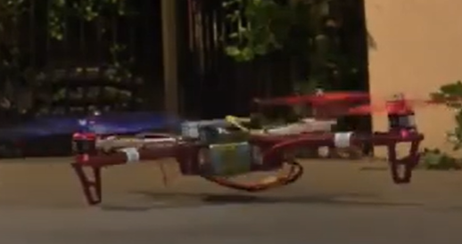

*Figure 38 - UAV hovering above the ground*

An attempt to correct the unstable spinning of the UAV was implemented as a frequency offset (increasing initial speeds of the “weaker motors”, after the first few seconds of the PWM ESC initialization period). The PWM signals that received this offset were selected by a test that would watch each motor while uniformly increasing the speed of each motor. The last motor to lift off of the ground would receive this offset in speed, to compensate for the slower motor speed/lack of lift. After optimizing the initial speeds of each motor (by decreasing the frequency after ESC initialization), the UAV gained some stability yet was still unable to reliably hover in the air for more than a few seconds.

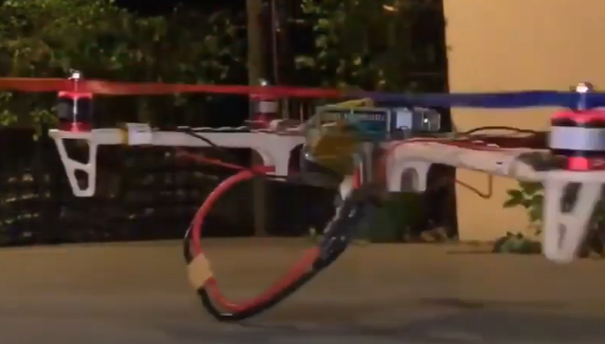

*Figure 39 - UAV After Frequency Offset Modulation*

Final tests concluded that the UAV is capable of flight, but needs some sort of feedback loop to adjust PWM frequencies based off of the acceleration and gyro values of the UAV. In its current state, the UAV does have the hardware and software to receive live acceleration and gyro telemetry, it just needs to be correctly implemented.

3. Conclusions

*Conclusions –* In conclusion, our UAV Quadcopter succeeded in all of our goal objectives, asides from stabilization. Our primary goals included programming and implementing our own Flight-Controller (Raspberry Pi 4), designing a printed circuit board to interface between the Raspberry Pi 4, battery, ESC’s and motors (while also being a crucial portion of the UAV’s chassis, mounting not only the Raspberry Pi 4, but also mounting onto the arms and holding the battery) – and finally, making the UAV lift off of the ground without and support equipment connected to it. All three of these above-mentioned goals were met. The Raspberry Pi 4 took control as the Flight-Controller after many hours of testing different PWM signals into the ESCs/motors. Successful control of the brushless motors was achieved with a PWM value of 54 % duty cycle and 590 Hz, initializing the ESC’s to work within an acceptable range for frequency inputs. The frequency of each PWM signal would be decreased to increase motor speed, or increased to decrease motor speed. The two DPIE (Digital Power Interface Electronics) boards not only mechanically supported the Raspberry Pi 4 (also battery, and arms), but they also supplied power to the Raspberry Pi 4, amplified PWM signals, and housed the MPU6050 gyro accelerometer IC to deliver necessary stabilization telemetry in order to eventually control the UAV as it hovers (this gyro/accelerometer data was never implemented to control the UAV, but it functions as intended). During final tests, we were able to verify that the UAV was capable of flight – lifting itself off of the ground at only half of the max motor speed. We also verified that the UAV is not capable of stable hovering without some kind of feedback loop communication from the MPU6050. The UAV was tested as an isolated system, controlled over WIFI (SSH), proving to us that the hardware performs well enough for the UAV to fly reliably. The software is the final piece missing to allow this UAV to have stability in flight.

References

[[1] Raspberry Pi 4

<https://www.raspberrypi.org/documentation/usage/gpio/>

[2] ESC

<https://www.getfpv.com/spedix-is30-2-4s-30a.html>

[3] ESC & Brushless Motor

<https://howtomechatronics.com/how-it-works/how-brushless-motor-and-esc-work/>

[4]MPU6050

<https://circuitdigest.com/microcontroller-projects/mpu6050-gyro-sensor-interfacing-with-raspberry-pi>

[5] BR2216 810 KV 2-4S Brushless Motor

<https://www.racerstar.com/racerstar-racing-edition-2216-br2216-810kv-2-4s-brushless-motor-cw-or-ccw-for-350-380-400-450-rc-drone-fpv-racing-p-59.html>

[6] Brushless motor Theory

<https://www.renesas.com/us/en/support/engineer-school/brushless-dc-motor-01-overview>

[7] Propeller shape and direction position

<https://oscarliang.com/choose-propellers-mini-quad/>

[8] Propeller factors

<https://www.unmannedsystemstechnology.com/2017/12/selecting-drone-propeller-blades-considerations/>

Biography

|  |
| --- |
| ***Chad Ryan*** *is currently finishing his undergraduate studies at California Polytechnic State University, Pomona and is graduating in the Summer of 2021 with a Bachelor’s Degree in Electrical Engineering. He has been interning for JPL since November 2019. At JPL he has been testing, studying, and designing payload electronics on the JPL NASA Lunar Flashlight infrared spectrometer spacecraft.* |

***Kory Shopp*** *is an Electrical Engineering student at California State Polytechnic University, Pomona (2018-2021). He is graduating with his BSEE in May of 2021.*

***Peter Tiet*** *is an electrical engineering student at California State Polytechnic University, Pomona and is graduating Spring 2021. He was an electronics team member of Cal Poly Rose Float where he has been testing animatronics and developed the internal framework and power distribution for the float electrical architecture.*

***Liam Yeargin*** *is an Electrical Engineering student at California State Polytechnic University, Pomona (2016-2021). He will be graduating with a Bachelor of Science in Electrical Engineering May 2021.*

Contributions

*Chad Ryan – Raspberry Pi 4 Python programming, printed circuit board design, printed circuit board population/soldering, final build integration, ran tests on subsystems and entire system, performed research and overall design for subsystems and entire system, produced a method for ESC Flashing.*

*Peter Tiet - Researched different types of ESCs at the component level and supported testing the flashing of the ESCs. Researched different types of motors and propellers and assisted in the selection of both of them. Researched on characteristics of the MPU6050 and assisted in final test of the drone.*

*Kory Shopp - assisted with research and supported testing of the components being used on the Quadcopter. Also assisted in early-stage Python programming, and final tests of the drone.*

*Liam Yeargin- supported component selection for the DPIE (Digital Power Interface electronics), battery/power system design & supported final tests of the drone.*

|  |
| --- |
|  |